**Multi-antenna user guide.**

This version contains modifications to the original FGI-GSRx code found here: <https://github.com/nlsfi/FGI-GSRx>

The zipped folder should track multiple RF streams in a hybrid diversity implementation.

**General FGI-GSRx Configuration** (you do not have to follow this, but this is how I set my workplace up)

Add Path MATLAB (with subfolders): should look something like this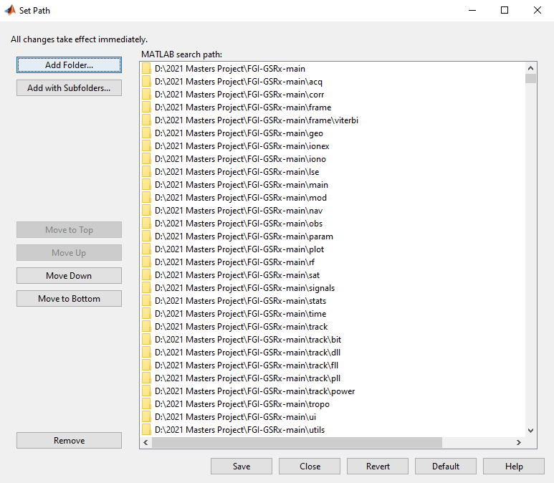

**General Configuration information:**

My settings txt files are found in the **main** folder. They read signals from a signals folder and spits the results in main. Not sure why I don’t have to specify path, maybe something to do with MATLAB set path. The generated files can be moved.

**Diversity Configuration Information**

To change tracking modes, delete files listed in ‘Changed files’ and rename the corresponding old/diversity/single/hybrid to deleted file.

Single diversity example: Delete doAcquisition.m and copy doAcquisition_diversity.m, rename doAcquisition_diversity.m to doAcquisition.m. Likewise for GNSSCorrelation with GNSSCorrelation_single.

Folders with changed files:

* Acq
* Corr
* Track
* main

Each folder where files have been changed is appended with

* old: original FGI-GSRx file
* diversity: supports single or hybrid diversity mode
* single: supports single active antenna diversity mode only
* hybrid: support hybrid active antenna diversity mode only
* 2/3/4 in GNSSCorrelation: supporting files for multiple RF streams

If file is appended with diversity then no file changed necessary when moving from single to hybrid (vice versa)

Changed files:

* **Acq/doAcquisition.m**: Support extra IF streams
* **Corr/GNSSCorrelation.m**: Changed to implement diversity mode
* **Main/gsrx.m**: extracts multiple acq results and update acqData struct with strongest antenna code and carrier results. Also appends antNum representing strongest antenna
* **Track/doTracking.m**: opens multiple RF files and tracking streams
* **Track/initTracking.m**: update antNum data from acquisition

Txt file information:

* track_multi.txt: multi antenna RF stream tracking config file
* Read_data.txt: reads matlab.m file
* Track_signal.txt: tract single RF stream

Note: getDataForAcquisition2/3/4: Pulls different IF stream name (easier than manipulating string names). These do not have to be deleted as files appended with old do not call them. getDataForAcquisition is unchanged.